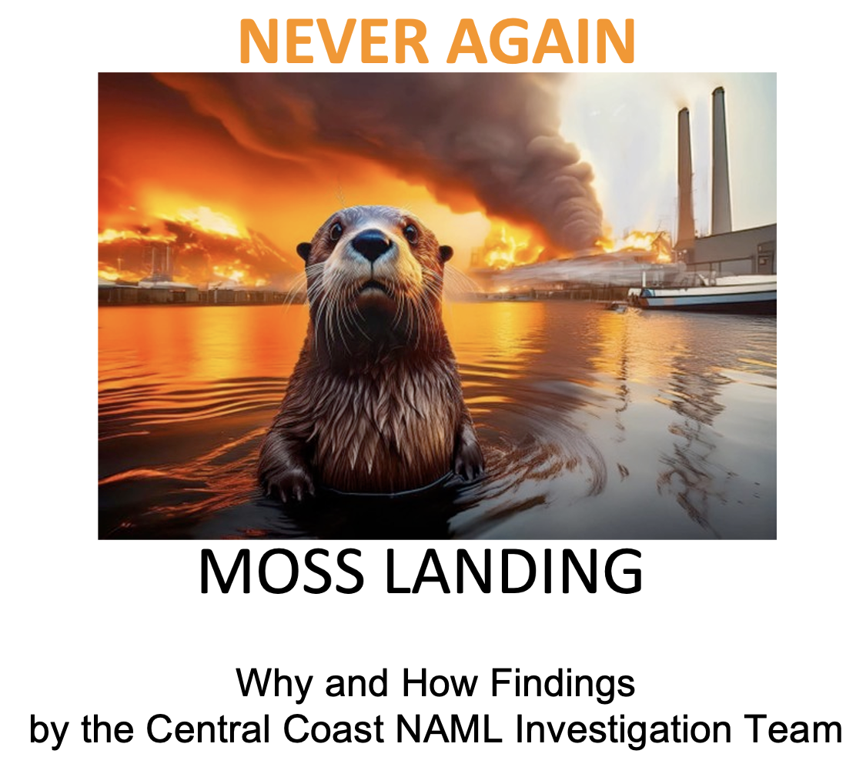
To: Monterey Board of Supervisors Jun 24, 2025
168 West Alisal St. PO Box 1728, Salinas CA 93902
1st Floor
Salinas CA 93901
(831)755-5066
cob@countyofmonterey.gov

CC: California Public Utilities Commission
Attn: Alice B. Reynolds, President
300 Capitol Mall, Suite 500
Sacramento, CA 95814
1-800-649-7570
https://www.cpuc.ca.gov/consumer-support/file-a-complaint/complaints-about-cpuc

CC: California Department of Toxic Substances Control
Attn: Katherine M. Butler, Director
1001 I Street
Sacramento, CA 95814
1-510-540-3003

CC: California Coastal Commission
Attn: Dr. Kate Huckelbridge, Executive Director
45 Fremont St., Ste 2000
San Francisco, CA 94105
415-904-5200
ExecutiveStaff@coastal.ca.gov
CC: California Energy Commission
Attn: David Hochschild, Chair
715 P Street
Sacramento, CA 95814
916-654-9595
publicadvisor@energy.ca.gov
From: California Never Again Moss Landing, Stakeholder Group
Ed Mitchell, Lead Investigator
70 Carlson Rd 93907
Salinas CA 93907
(831) 663-3021 msg machine
edmitchell70@hughes.net

Subject: Never Again Moss Landing (NAML), public investigation — January 16th Moss Landing BESS fire

Supervisors,

The coordination committee of the Never Again Moss Landing (NAML) Stakeholder Group, of over 4,900 citizens, is providing you with the findings of our 120-day investigation into how and why the Vistra storage facility failed. Included are twenty questions that the Public Utility Commission should ask during the State’s formal investigation of the Vistra storage disaster. We are not volunteer stakeholders. We were forced into it in late-January 2025 because our families, homes, farms, boats, and businesses, as well as the local sea and estuary were exposed to the massive pollution cloud carrying heavy metal, dioxins, and PFAs that washed across our Central Coast communities while the Vistra indoor lithium battery storage building burned to the ground, during the period 16 – 22 January 2025.

As a stakeholder group, it is fair and reasonable of us to offer public insights into the disaster, as well as petition our government with requests that critical technical, operational, and regulatory questions be answered, along with requests for recovery help and safe cleanup. In that spirit, we define the disaster as including the complete loss of the biggest indoor lithium battery storage facility in America, with near- and potentially long-term public health impacts, along with potential negative impacts on the Central Coast’s citizens, tourist industry, local businesses, environment, and agricultural region.

Three NAML members joined together to conduct an unbiased investigation. All three have emerging technology expertise. One was a former certified Department of Defense material acquisition manager with 15 years of experience developing and testing National Missile Defense (Star Wars) equipment in the Army and at Lockheed Martin. One was a former federal EPA field specialist who inspected and enforced code. One has a degree in biochemistry and worked in an environmental toxicology lab, studying heavy metals.

The investigation team’s blunt and critical comments in this report are not meant for the many hardworking, ethical good people in Vistra and the California Public Utilities Commission (PUC). Rather, this investigation and its findings are directed at the senior leadership in those organizations who made flawed decisions which contributed to the destruction of the largest indoor lithium battery storage facility in America. A disaster that sent toxic clouds across protected coastal areas and critical agriculture acreage, while also impacting thousands of Central Coast Californians, many of whom almost certainly will suffer from significant long-term health effects.

The report is structured as follows:
1 Goals
2 Investigation Focus
3 Evidence Sources
4 Fire Event Facts
5 County-Level Details & Findings
6A Operator-Level Details & Findings
6B Operator Risk Details & Findings
7 Regulator-Level Details & Findings
8 Summary Findings
9 Needed PUC Investigation Questions

<<<<<<<<<<<<< >>>>>>>>>>>>

Section-1 Goals
Our investigation has three goals: First, identify needed corrective action so never again will a community be damaged by a massive indoor battery fire as our community has suffered. Second, identify needed operator and regulator corrective actions so the energy storage industry can succeed and can safely operate. Third, have existing or emerging indoor storage facilities in California inspected to ensure they do not have any storage-weaknesses as identified in the Vistra indoor storage disaster. This inspection must include a warehouse fire risk assessment of how fast a thermal runaway fire would spread in the existing or proposed storage building.

Section-2 Investigation Focus
As the evidence came in our team focused more and more on two disturbing concerns. The first is a focus on weaknesses in designing the warehouse for safety. The second is on regulator weaknesses.

#1 Operator performance focus: Did the storage facility operator (Vistra) install and operate a high-risk single-building, high-quantity, indoor storage layout, that was prone to completely burn up all the batteries on a floor if uncontrolled thermal runaway erupted?

#2 Regulator performance focus: Why have State regulators failed to gather and report battery fire hazardous chemicals, such as dioxins, PFAs, heavy metals, and other hazardous chemical sampling data that might show dangers to first responders, worker health, the public, local businesses, the environment, and agriculture fields?

Because photographs, diagrams, and charts are much of the evidence we inserted them with the text.

Section-3 Evidence Sources
The findings of this investigation were built from reviewing the following 13 public and internet sources spanning the period: 2017 thorough 15 April 2025. This is an evidentiary investigation where our sources are named with each image, diagram, or chart to substantiate a finding.

S-1: 2019 & 2020 County Planning Commission permitting documents and exhibits,
supplemented with the Vistra project Initial Study, as well as the County’s January 2025 rapid response website.

S-2: Vistra, and California PUC public documents, including Vistra’s 4 September 2021 Incident After Action Report. Our investigation team calls this the first smoke and suppression incident (S&S).

S-3: Press Releases from senior Vistra executives and from LG Energy (rack-supplier)

S-4: Ten PUC websites, including the regulator’s and the Electric Safety and Reliability Branch’s mission statement, along with the PUC’s Energy Storage Procurement Study: Attachment F, Safety Best Practices, as well as the PUC’s March 13, 2025 ESRB-13 resolution documentation.

S-5: Vistra-operator and PUC-regulator storage photographs.

S-6: Multiple TV and newspaper online reports, often with fire and pollution cloud images, including the New York Times, LA Times, Epoch Times, and NBC Bay Area.

S-7: Eye-witness observations of the 6-day fire by multiple members of the Never Again Moss Landing coordination committee who lived within two miles of the fire, as well as others who watched the January 16, 2025 fire from hilltop vantage points in North Monterey County.

S-8: Eye-witness observations by people who were given tours of the Phase-1 building during refurbishment and/or after batteries were stored in the building. Such people included California Senator Laird, Monterey County Board of Supervisors staff members, and people who worked in the Phase-I indoor storage building.

S-9: Minor and significant symptom reporting on the Never Again Moss Landing Facebook symptoms page. Plus, symptom reports gathered by the Monterey County Health Department.

S-10: Heavy metal sampling taken within the Elkhorn Slough by San Jose State College’s Dr. Aiello just days after the fire ignited.

S-11: 124 “Ghost Wipe” samples gathered by 124 citizens under NAML direction seven days after the fire began.

S-12: A study conducted by the United Kingdom Royal Society of Chemistry dated Dec 2022: Determination of heavy and other metals generated during thermal runaway fire testing.

S-13: We could not find ANY State agency that has reported sampling results for hazardous materials release of heavy metals, dioxins, PCBs, chlorinated compounds, or polyaromatic hydrocarbons (PAHs) in the fire’s vapor/cloud during the Vistra disaster, nor for 7 earlier battery storage fires in California during the 3-year period from April 2022 through April 2025.

Section-4 Fire Event Facts
See Slide 1.

On January 16th 2025, NAML eyewitnesses, along with thousands of Central Coast citizens, watched news coverage by KSBW and KION TV reporters describing the uncontrollable fire at the Vistra Phase-I lithium-ion battery storage facility situated next to the Moss Landing harbor. We do not know what triggered the thermal runaway ignition incident. We do know that battery thermal runaway which could have begun with the degradation and overheating of a single battery created a rapidly expanding uncontrollable fire. See the report here:
https://www.sciencedirect.com/science/article/abs/pii/S2352152X24009575
https://www.sciencedirect.com/science/article/abs/pii/S0957582023004858

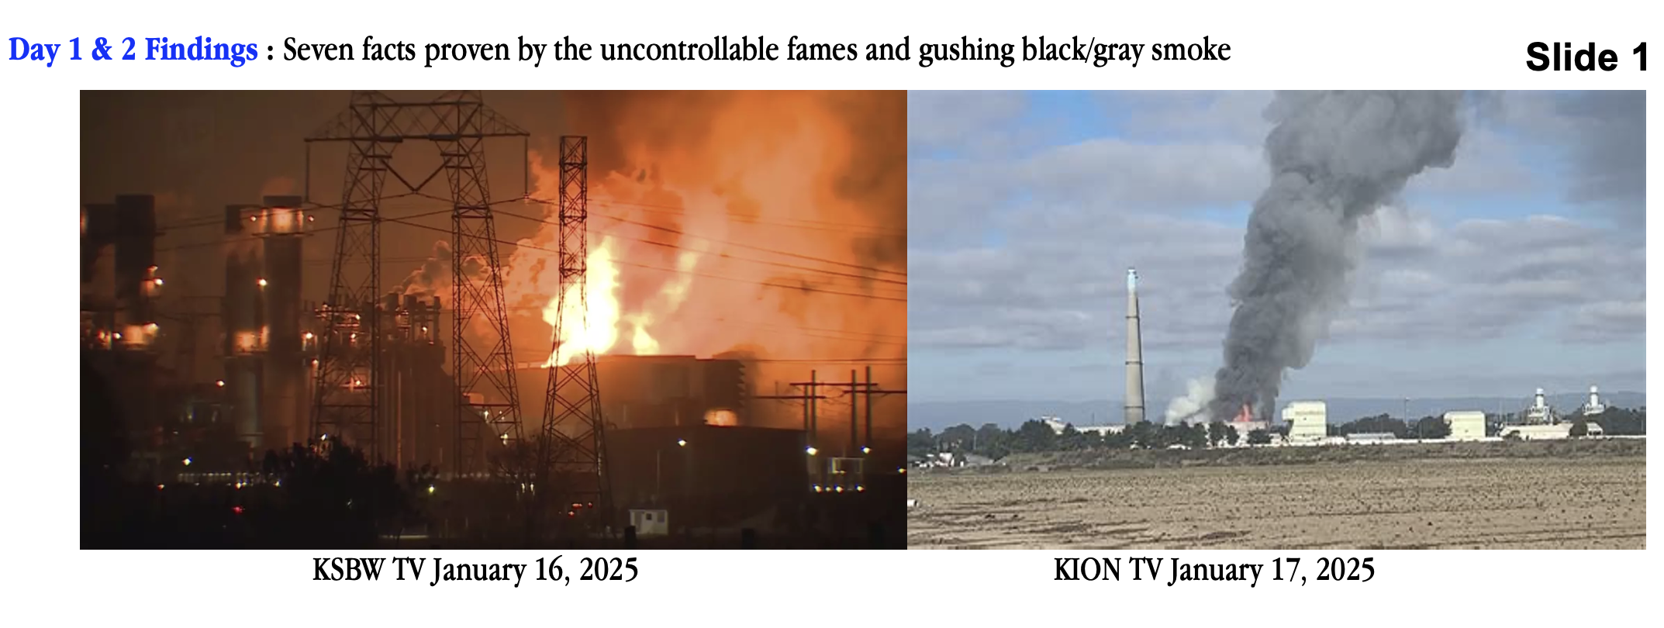
However, the massive flames and gushing black/gray smoke rolling out of the Phase-1 storage building prove seven facts irrefutable by the Vistra operator and by any California State regulators. The seven facts are listed below:

F-1: During 16 thru 22 January 2025, the biggest indoor lithium battery storage facility in
America burned to the ground.

F-2: The building’s suppression system failed to suppress because it either did not exist, was not rapidly initiated, was inadequate for the number of batteries exposed to thermal runaway heat, or it failed to operate. In fact, reporting by NBCUniversal’s Jaxon Van Derbeken on April 28, 2025, revealed that in the weeks before the conflagration, Vistra modified its fire suppression system to actuate more slowly after several incidents occurred under the approved suppression system. See the report here:
https://www.msn.com/en-us/public-safety-and-emergencies/health-and-safety-alerts/experts-question-pre-fire-change-to-key-moss-landing-safety-system/ar-AA1DOvJj

F-3: The building’s containment system failed to contain.

F-4: Vistra had failed to provide an emergency plan to the community which reflected the full dangers of thermal runaway. The incident was a danger to first responders closing off the disaster site, drivers on Hwy 1, local businessowners, and to local citizens and communities ordered to evacuate. See the report here:
https://neveragainmosslanding.org/wp-content/uploads/2025/04/LFP-Batteries-Are-Dangerous-2-24-25.pdf

F-5: The black and gray smoke was laden with pollution blowing east inland into North Monterey County and then spreading to adjacent counties.

F-6: The operator’s storage and safety efforts failed, despite Vistra’s repeated statements that the facility was being safely managed and operated.

F-7: The PUC regulator failed its mission statement as stated on the PUC’s Electric Safety and Reliability Branch (ESRB) web page. We quote: “to ensure that the facilities are operated and maintained in a safe and reliable manner to protect and promote the public health and safety.

See Slide 2. After the initial six-day fire ended, study of the burnt building and hundreds of feet of black burnt residue proved three additional irrefutable facts:
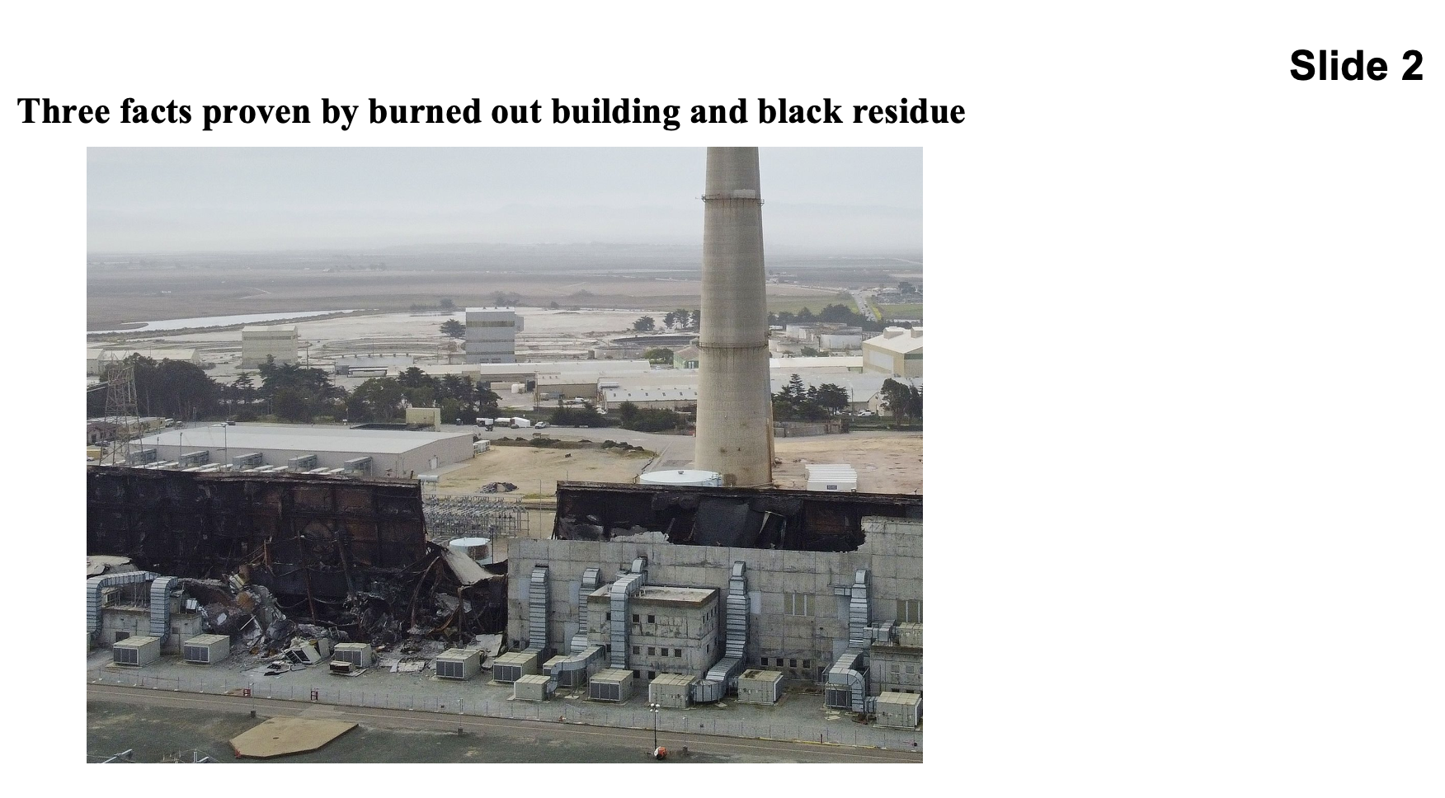

F-8: The three-story building’s upper two floors collapsed onto the bottom floor because metal support beams melted or slumped from the high heat generated by the burning batteries. Burning lithium batteries self-generate oxygen as a byproduct which acts as a blowtorch, further energizing the intensity and energy of the fire. Estimates of temperatures range as high as 5,000 degrees Fahrenheit, adequate to vaporize the materials within the building, creating nanoparticles which traveled widely throughout the region on documented air currents that spread well beyond the boundaries of Monterey County.

F-9: The building’s interior was gutted by the fire, leaving a building-long pile of black pollution residue.

F-10: Unstable exterior walls and tons of polluted residue will have to be removed as part of site cleaned up. A post-fire news release by Vistra notified the County and public that approximately 80% of the batteries were burned up and 20% remained to be de-linked from the grid.

Fire Responder Facts

F-11: The PUC and Federal authorities arrived at the huge Vistra Battery fire unprepared for such a fire. For example, while the fire was burning, neither the PUC nor any other State agency arrived with meters or means to measure heavy metal or other fire pollutants such as dioxins in and around the fire site. While the fire was burning, neither the PUC nor any other State agency drove into the Royal Oaks and Prunedale downwind area, to take air samples, where the pollution cloud lingered down to ground level. While the fire was burning, neither the PUC nor the California Health Department, issued a medical alert to hospitals in Monterey, Santa Cruz, and San Benito counties that a hazardous fire had occurred and to expect patients to appear with throat/lung issues and skin burns, along with medical instructions about what to do when such patients appear at their emergency rooms. Meanwhile, the EPA deployed ground monitors to measure for hexafluoride which is lighter that air and therefore did not blanket the ground where the monitors were located. Also, the EPA only tested for 2.5 μg and above, of particulate matter. However, the intense energy of the fire released up to 5000 tons of highly toxic materials vaporized into nano particles smaller than 2.5 μg. Additionally, they did not sample for black carbon, which is cheap and easy to do.
For more, follow this link:
https://www.osha.gov/sites/default/files/publications/OSHA4480.pdf

F-12: No emergence-response drones were stored at Vistra’s facility or with the local emergency response organizations, or later supplied by the EPA, or the CPUC. So, fire responders were NOT provided with aerial observation of on-site and off-site conditions. Neither was plume-level sampling conducted.

F-13: No one involved in the January 16 response effort had the means to immediately fingerprint what chemical pollutants were in the plume nor, days-later, identify the strength of lingering in-the-air pollutants.

Public Response Facts
Meanwhile, San Jose State College, announced on January 27th 2025 on its media webpage a major find by its team working for the last five years monitoring the health of the Elkhorn Slough. There, Dr. Aiello, went into the slough after ash residue started falling from the plume of smoke. At previously sampled areas, he found the Cobalt, Manganese, and Nickel heavy metals used to make the stored batteries lying on the ground in the slough outside Vistra’s property. He verified concentrations “hundreds to thousand-fold times higher than historical measurements,” as far as two miles from the Vistra industrial site.

Plus, after the fire started, NAML members began asking if the County or State would do surface samples at their property miles from the burn site. When NAML coordinators learned no agency was planning to perform downwind sampling, coordinator Brian Roeder paid for 124 sample kits and analysis by ALS Lab. Then under the guidance of the environmental hygienist firm, BioMax Environmental, sample takers were trained in how to take “ghost wipes” and maintain chain of custody of the sample kits. Sampling began seven days after fire ignition prior to an incoming winter storm, beating the inevitable environmental degradation of weather impacts. Samples were taken as close as 0.4 miles and as far as 46 miles from the burn site to determine to what degree were four heavy metals deposited across a 800 sq. mi area covering the three counties surrounding the Monterey Bay National Marine Sanctuary.

The result: dozens of wipe samples were returned showing all three heavy metals in the same proportions as Dr. Aiello found, specifically Nickel to Cobalt 2:1 ratio. To the best of our knowledge, no effort was made by Vistra, the State, or the local jurisdictions to test for such downwind residue before, during, or after winter storms had rolled through the region.

See Slide 3. After the initial six-day fire ended, over 647 NAML Facebook members reported minor to significant symptoms triggered after breathing in metal-tasting and or metal-smelling vapor. People with symptoms stretched along the Monterey Bay Coastal arc from Santa Cruz in the north passed Watsonville to Salinas, to Pacific Grove, as well as south down the Salinas Valley to Greenfield. Subsequently, the Monterey County Health Department reported over 1,000 people with air pollution symptoms. The data from these reports are shown on the home page of the NAML website: www.neveragainmosslanding.org.
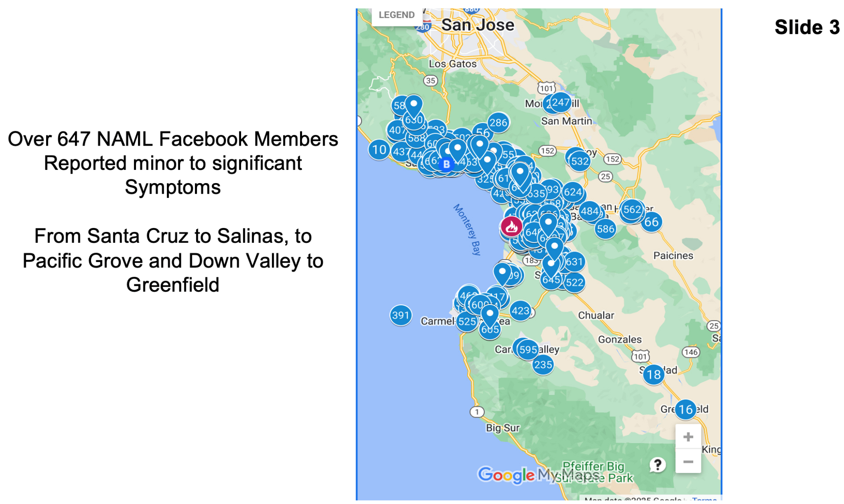
See Slide 4. Meanwhile, no California state regulator or agency made any attempt to sample downwind vapor conditions for heavy metal and dioxin exposure beyond the fire site. For example, the ground-level lingering cloud near Castroville Boulevard and San Miguel Canyon Road on January 18, 2025. Nor did State employees sample and report soil and residue samples inside or outside the perimeter of Vistra’s industrial footprint. Neither did the State conduct and report vapor/cloud sampling during or after each of 7 previous large California BESS fires spanning 3 years from 5 April 2022 to 5 April 2025, that were listed in the PUC’s March 13, 2025 ESRB-13 resolution documentation.
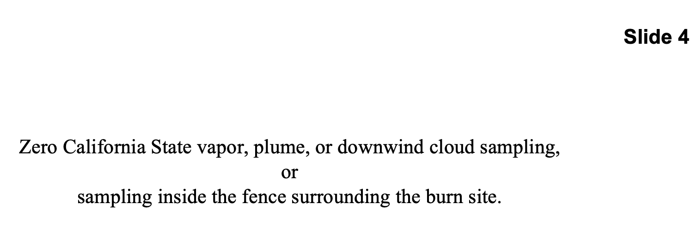

However, Michael Polkabla, a local professional industrial pollution identification and sampling expert was quoted in an Epoch Times news article released March 14, 2025, “...He was shocked that EPA was only monitoring for two airborne hazards, 2.5 micrometers in diameter particulate matter and hydrogen fluoride, used to monitor air quality. They didn’t even consider the other contaminants involved. They should have immediately looked for heavy metal.”

Moreover, sampling for 2.5 micrometer particles did not measure or account for matter that was vaporized into far smaller particles due to the intensity of the fire. This was not the first significant industrial-scale BESS. fire. It has been shown that they burn at incredibly high temperatures that do not destroy the battery components, but rather vaporize them into a mist-like cloud that can travel great distances.

We fail to understand why the EPA did not test for the actual mix of battery fire emissions and material size. The EPA continues to this day to claim that dangerous levels of toxic materials did not emanate from the fire. This position is misleading and dangerous to public health and public understanding of the fire and its aftermath. We are not aware of any efforts organized by state or federal officials to measure or determine the health condition of those who were exposed to the toxic plume.

<<<<<<<<<<<<< >>>>>>>>>>>>

Section-5 County-Level Permitting Details
See Slide 5.
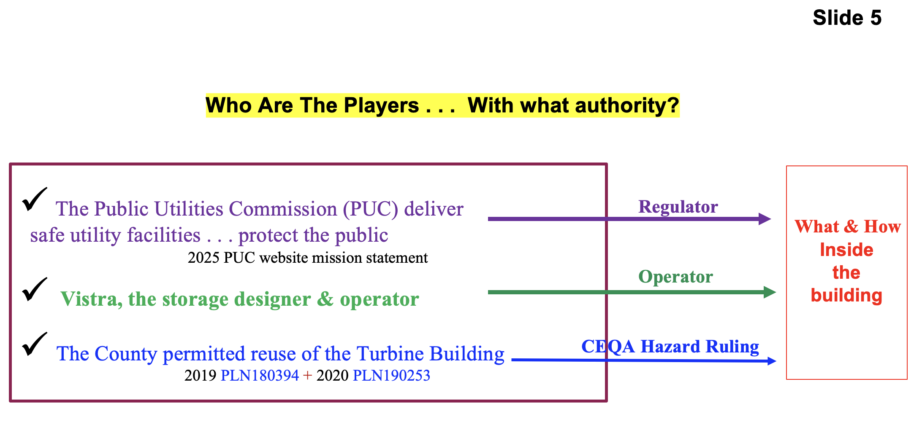

At the county level, prior to 2019, Vistra petitioned Monterey County to permit their Phase-1 and Phase-II lithium-ion battery storage projects to be approved to store up to 200,000 batteries. The projects included storing batteries within the old turbine building and a to-be-built new building located on the historic energy production site across Highway-1 from Moss Landing Harbor and the Moss Landing boat and business district.

At that time, the California Energy Commission (CEC) did not have the authority to be involved in battery storage project approval or denial, which was later authorized in June 2022 via Assembly Bill 205. Thus, the PUC was the State’s legal regulator of Vistra’s public energy and storage facilities before and after Assembly Bill 205 was approved.

County Planning Department permitting documents 2019 PLN180394, 2020 PLN190253, and the accompanying “Initial Study” document show that the project review and approval cycle lasted 30 days from January 29, 2019 through February 28, 2019.

The Initial Study and project application included the following facts:
#1: Lithium-ion nickel-manganese-cobalt (heavy metal batteries) would go into a Battery Module which would go into a Rack which would go into a System. (In this report for descriptive purposes we use the term row-unit in lieu of system).

#2: The equipment was designed with redundant fire safety features (such a sensor monitoring, suppression and containment) at the cell, battery module, rack, and row-unit level.

#3: The row-units would be double-stacked.

#4: Batteries would be stored/positioned on the first and third floors of the Phase-1 refurbished turbine building.

#5 The batteries would have a 20-year operational life

What was not clarified in the Initial Study and permitting exhibits, was a description of the building’s suppression system which later failed on January 16, 2025. So, it is unknown to this investigation team if it was a new large-volume water spray system or the original turbine water suppression system upgraded with Vistra provided control software.

During the permitting review, Vistra and other supporting parties championed the fact that the battery storage and reuse technology was a great green new technology because it was replacing older fossil-fuel polluting facilities – or words to that effect. For example, the Sierra Club was one of the supporters urging the Planning Department to approve the Vistra project.

Unfortunately, the champions failed to add three crucial words to the pitch for green technology. Three words that would have made their pro-project pitch more forthcoming and accurate. Those three words are as follows: . . . it’s a great green technology when it works. Please recall Slide-1’s day and night pictures of the uncontrollable fire and smoke, revealing the community and environmental safety hazards that result when ion battery storage technology did not work.

One Planning Department Commissioner asked about “fire,” and was informed that any large energy or storage facility ran the risk of a fire. However, as documented in the Initial Study redundant safety features would be in place to rapidly respond to indications of rising heat or fire. However, the term “thermal runaway’ was not found in the Initial Study or the County permitting documents. Neither does the planning document address if the Fire Department has the resources and equipment required to meet the well-known challenges of fighting a lithium-ion battery fire.

Unfortunately, five years ago, the County Planning Commission did not have the depth of information that this investigation team has about numerous fires at large battery storage facilities in and outside of the United States and California. Thus, the County did not conduct EIRs for the projects, concluding that the principal environmental impacts were from construction activities, not new technology operation, and that construction impacts were “less than significant” with mitigation measures. Then the Planning Commission recommended project approved the application with a mitigated negative declaration, stating “The project will not have the potential to significantly degrade the quality of the environment . . . would not create a significant adverse effect on humans.”

County-Level Finding:
Yes, it was asserted in 2019 that what would be reused or refurbished, like existing roads, cement pads, structures, etc., on the 69-year-old energy site would not impart a new environmental impact. However, what was environmentally hazardous about the heavy metal batteries and new storage technology going into the Moss Landing / Elkhorn Slough area was not assessed, as if no hazards existed. Vistra presented the project as a change of energy equipment for the purpose of “Green” energy generation. Furthermore, since there was no formal public challenge to the approval, it did not go before the County Board of Supervisors, nor to the Coastal Commission.
<<<<<<<<<<<<< >>>>>>>>>>>>
Section-6A Operator-Level Details
By merging the below listed evidence sources, this section details the indoor physical layout and distancing of stored items that Vistra chose to implement in its Phase-I facility:
>> Facts from the 2019-2020 Initial Study and permitting documents,
>> Quantity data from the January 21, 2025 Board of Supervisor’s emergency meeting
>> Vistra generated photographs from their website and the September 4, 2021 incident
>> Rack-supplier (LG Energy’s) June 17th 2021 press release photograph and text evidence

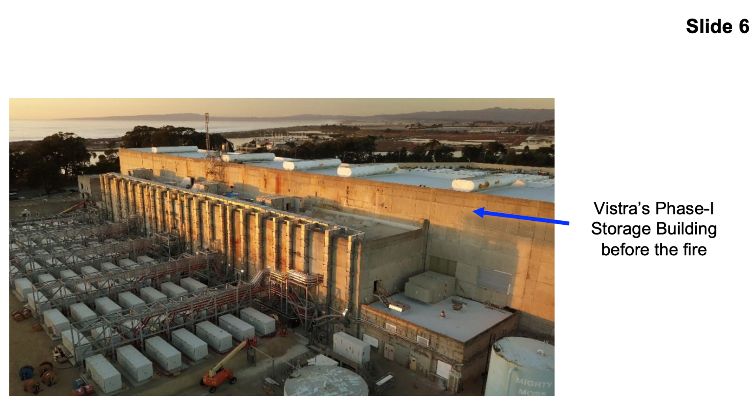
See Slide 6 Single Building:
Vistra’s re-purposed the turbine building on the energy storage site. It is the tallest and largest building shown on the slide. It is 800 feet long, of which 700 feet (more than two football fields) were used for battery storage based on Google Map measurements of the black burn scar.

High-quantity:
Vistra’s Regional Vice President and NAML coordinators attended the January 21, 2025 County Board of Supervisors’ emergency meeting after the initial fire died down. There, one of the supervisors asked the Vistra VP how many batteries were stored in the Phase-1 building. The answer was 100,000. Per the Initial Study, that quantity of nickel-manganese-cobalt batteries were stored in the first and third floors of the building. Based upon photographic evidence, this investigation team assumed, at least 50,000 heavy metal batteries were stored on each floor of the Phase-1 building.

See Slide 7. Double-stacked storage items:
Vistra website photo of double-stack racks (left-side of slide) combined with the rack-supplier’s (LG Energy) June 17, 2021 press release reveal 22 stacked batteries were inserted into TR1300 racks. Nine racks made up a row-unit. Then row-units were double-stacked. Thus, 198 batteries made up a single row-unit, while 396 batteries made up a double-stacked row. LG Energy’s press release text proudly explained that their “thermal runaway tested . . . double-stacked feature ... enabled . . . full battery capacity . . . without the need for major construction.” Thus, double-stacking allowed Vistra to position twice as many batteries in the same row-unit footprint.
But, every time a battery was added and when a rack was added and a row-unit was added the risk of failure went up. Why, because . . . more parts, more components = more risk of failure.
See the LG promotional Moss Landing video here:
https://neveragainmosslanding.org/lg-promo-for-the-moss-landing-b-e-s-s-racking-system/

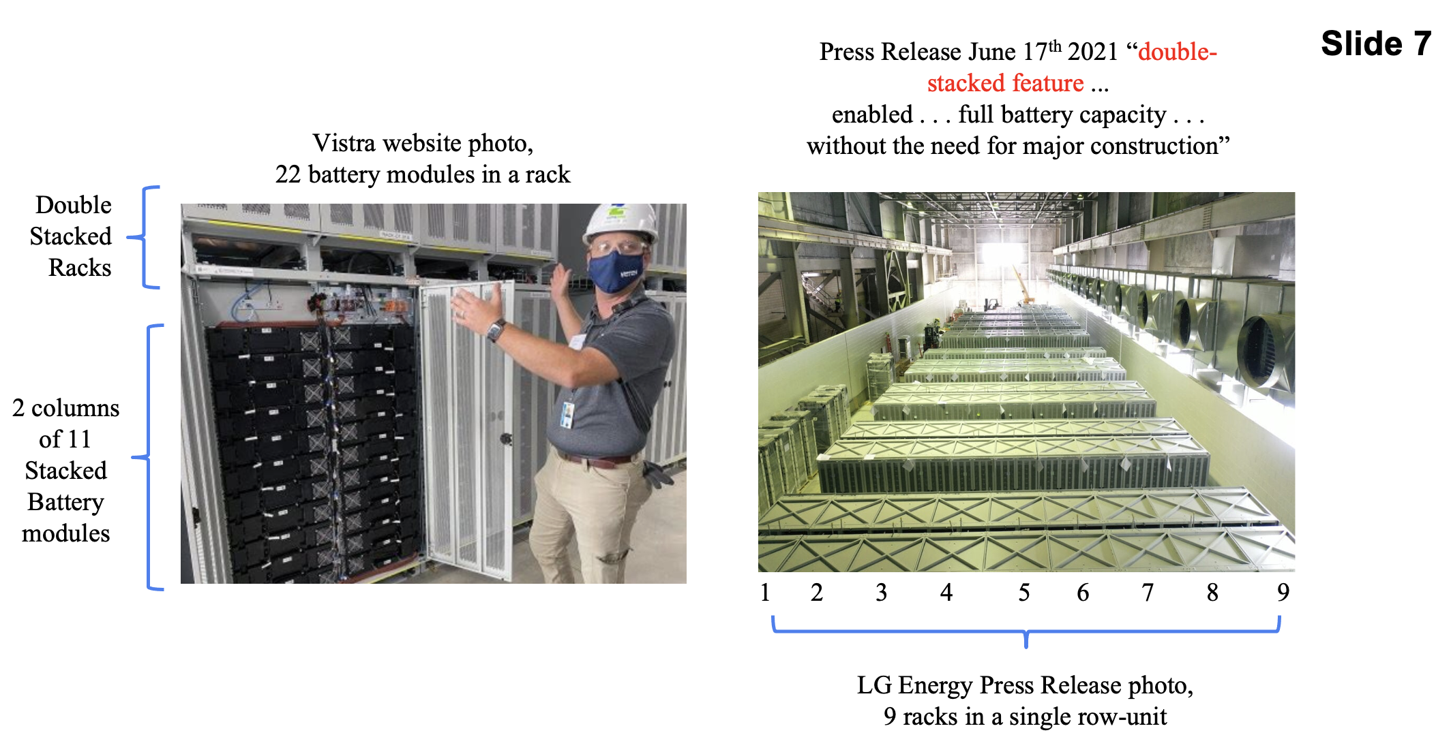

See Slide 8. Indoor Containment Distances:
Distance apart is a common containment method. So, how many rows were there and how far apart were they? The investigation team solved those questions by dividing 396 batteries within a row-unit into 50,000 batteries on the floor = 126 rows. Then, divided 126 rows into the length of the burnt containment room (700 feet) = 5 feet 6 inches of aisle space between rows. Meanwhile, stacked items had zero distancing.
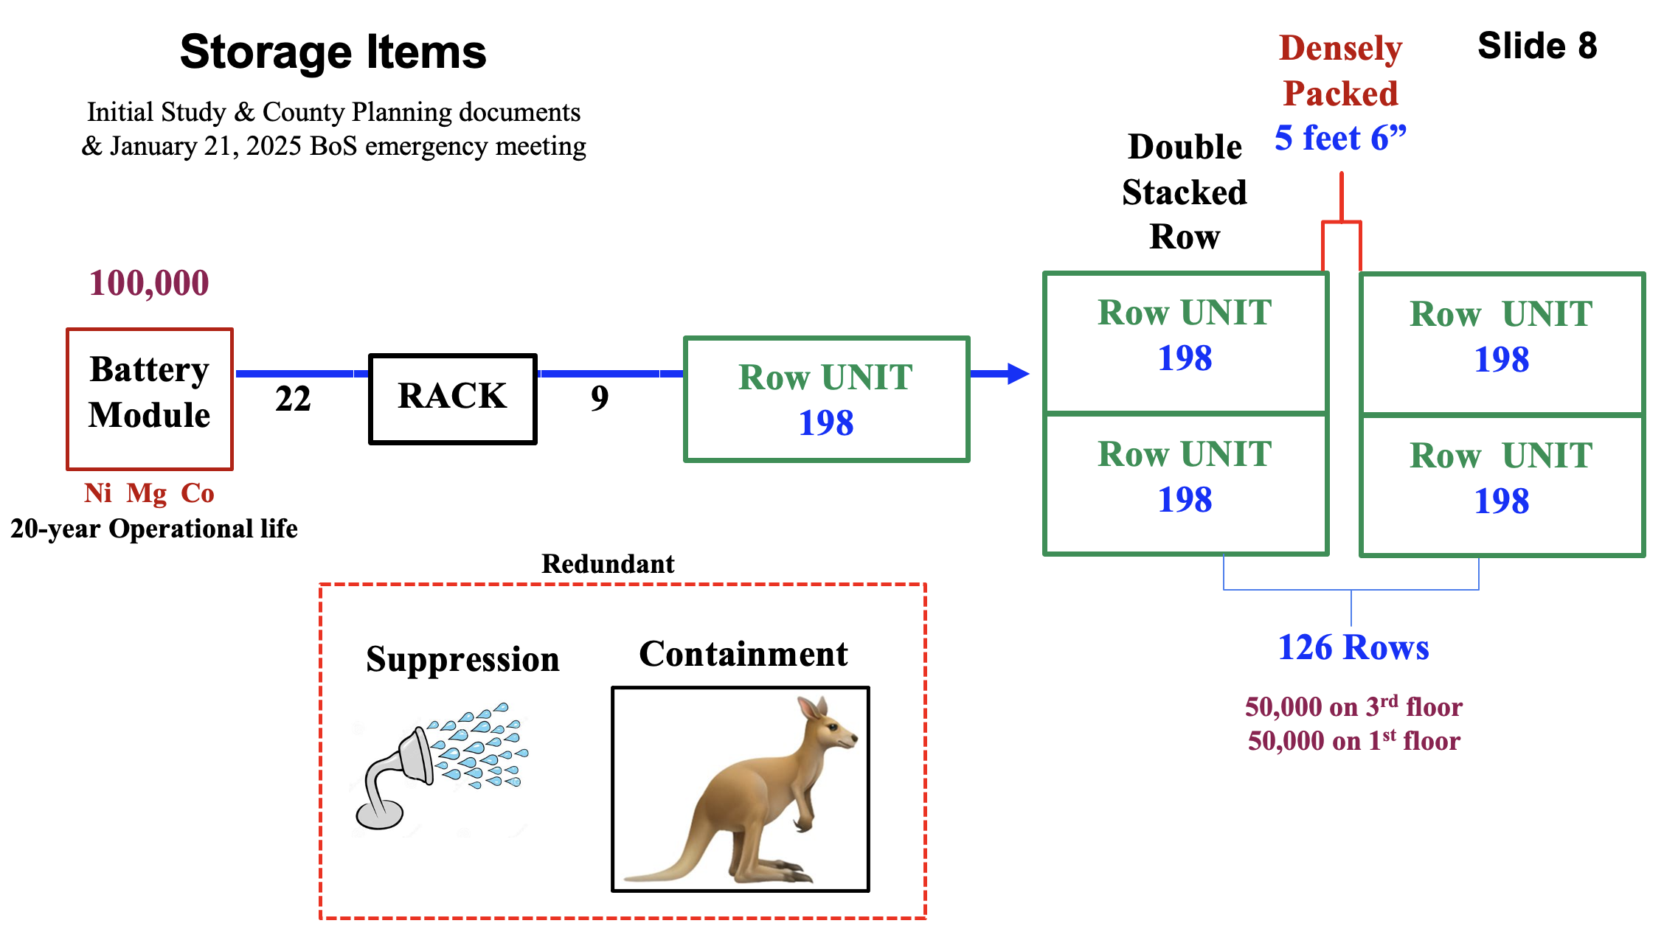
See Slide 9. All-or-nothing Indoor Storage:
The Vistra photo shows the third floor’s expansive storage area prior to battery installation, with no intervening walls, where at least 50,000 batteries were planned to be stored, along the full length of the floor. Thus, 50,000 batteries were eventually positioned PRONE, to be completely burned up if uncontained thermal runaway couldn’t be stopped by the building’s suppression system. However, if one or more, fireproof and firestop intervening walls had been constructed, the probability of all batteries on the floor catching on fire — would have been reduced. Plus, the large gap in the floor, if not closed, would allow toxic gasses, smoke, heat, and water to flow into or from the 2nd floor area and thus fail to achieve Underwriters Laboratories UL 1479 firestop safety standards to stop such spreading through a fire-rated barrier for a specified period of time.
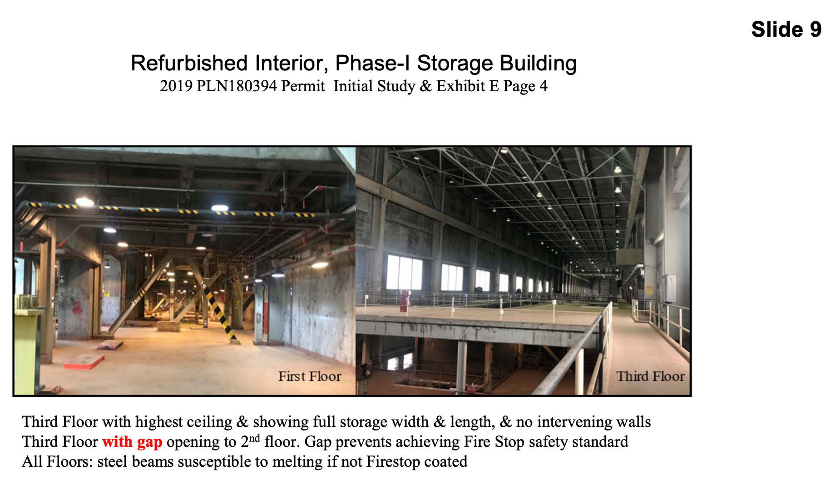
See Slide 10. Our investigation team requested that the County provide copies of the “as built” blueprints for us to determine if the gap extended to the 1st floor and was it ever sealed and how well it was sealed beyond fireproofing, to include firestopping. However, the County said they did not have the “as built” blueprints. Luckily, our determined research uncovered the image on Slide 10, showing there was a 3-story-high gap used to hoist racks and material to and from all three floors. So, at the date and time that the video was recorded, it appears that the Phase-1 building was a huge single-room where toxic gasses, smoke, heat, and water could easily flow through the gap to each floor.
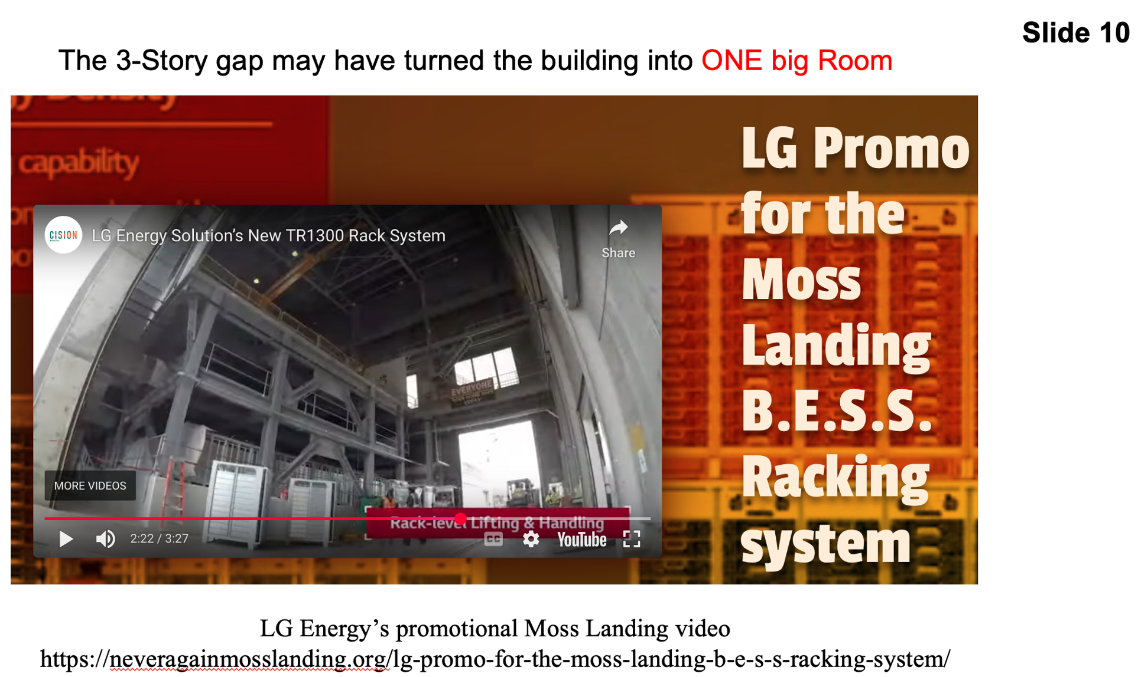

Notice the metal beams on the sides of the gap. Installing firestop on all Phase-1 metal beams would be a massive job. But, if not done, high thermal runaway heat would quickly melt support beams, collapsing the ceiling and upper floors onto the lower-stored batteries. Recall slides 1 and 2 confirming the massive fire occurred, was not suppressed, was not contained, and the upper floors collapsed.

However, Vistra’s Initial Study and permitting documents claimed the 1st floor storage area had fireproofing and a separate entrance door. But that documentation did not reveal the degree of firestop used to ensure the lower floor would not be impacted by toxic gases, smoke, heat, and water. On the contrary, as Vistra reported, the September 4, 2021 smoke and suppression (S&S) incident did leak water into the “lower” storage room; meaning the 1st floor.
See Vistra’s March 2022 report on the September 2021 fire event here:
https://neveragainmosslanding.org/wp-content/uploads/2025/05/Moss-Landing-Battery-Presentations-March-23-2022.pdf

Thus, in September 2021 it appears that there were not two storage rooms firestopped from each other. Instead, just a single-building single-room, storage design that is “prone” to fail and burn up all the batteries on all floors during thermal runaway. The investigation team does not know if Vistra added or improved firestopping after the 2021 S&S incident. Nor do we know the degree of post-fix software and water delivery testing performed to confirm the fixes would work.

See Slide 11. Actual Indoor Layout:
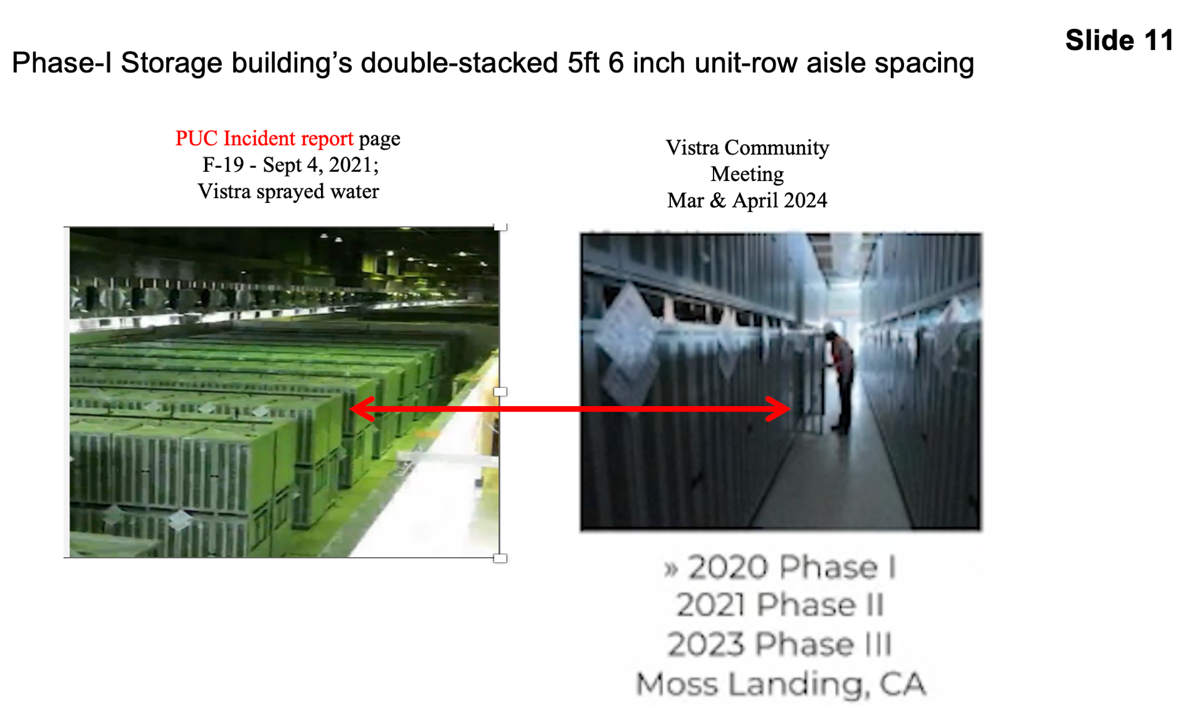
The left-side photograph on Slide 11 comes from the PUC’s incident report about Vistra’s Phase-1 September 4, 2021 loss of nearly 7,000 batteries because smoke sensors triggered water suppression spraying when the smoke wasn’t from any of the batteries. Unfortunately, leaks in the suppression water lines started shorting out properly operating batteries on the 3rd floor. Then the smoke sensors properly triggered more suppression water. Vistra added to the PUC’s report explaining that the suppression water flowed down to the “lower floor” and shorted batteries there. That leakage proved that the 3rd floor was not firestop sealed, where the incident started, to prevent water, gas, and heat from reaching down or up through the floor.

Even before reading the incident report, the height of the ceiling and the line of windows stretching to the far end of the room prove the photo is of the Phase-1 3rd floor. So, the slide shows the actual installed layout of the double-stacked row-units on the 3rd floor, as well as the narrowness of the separation aisles which were previously calculated to be 5 feet 6 inches wide. Supporting that calculation is the right-side photo that Vistra representatives showed to the public during Vistra’s community meetings in March and April 2024 down in Moro Bay where they were working to get public support to build a BESS located on the edge of that coastal town. The public raised questions about the incidents at Vistra’s Moss Landing Phase-1 BESS and Vistra presented them the right-side photograph showing a technician in an aisle between two row-units. Notice how close the employee’s head is to the opened rack, as well as how close his back is to the opposite row-unit. It is obvious from Vistra’s own photograph that the employee could easily touch each row-unit with outstretched arms, and that the physical spacing might be even narrower than the calculated 5 feet 6 inches.

Additionally, the left-side photo shows no intervening walls. Thus, the floor was a huge single room. Plus, if the floor gap shown on Slide 9 and Slide 10 was not sealed shut, firestopped, and fireproofed then the 3rd and 2nd floors were one big room, PRONE to completely burn up all the batteries on the floor, if uncontained thermal runaway couldn’t be stopped by the building’s suppression system.

See Slide 12. Indoor versus outdoor distancing:
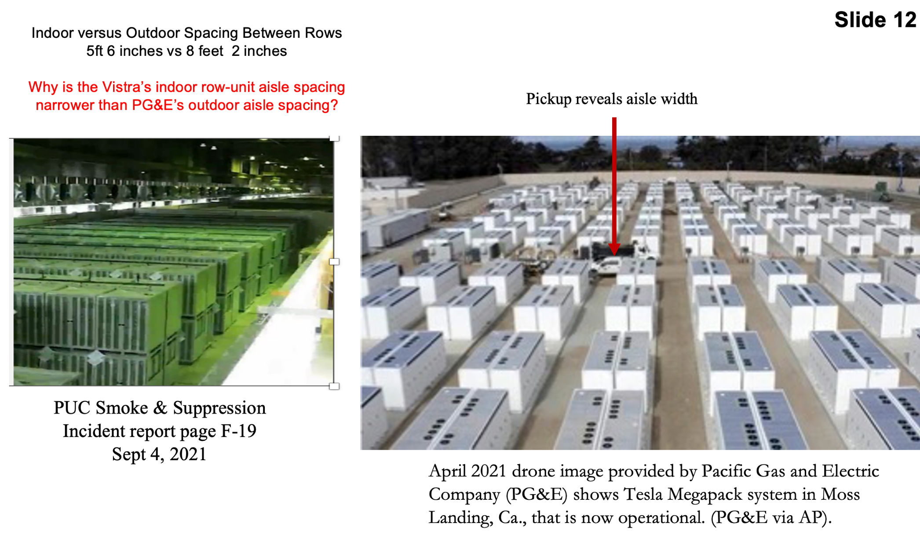

The right-side photo in Slide 12 shows PG&E’s outdoor storage yard as of April 2021, with a pickup truck parked beside a row-unit aisle. Visual comparison of that outdoor width versus the indoor aisle width in the left-side photo — appeared to the investigators as being wider than Vistra’s layout. To better assess any aisle width difference, we enlarged the photo. That revealed the aisle stretched from the center of the front wheel hub to the back edge of the double door. Measuring that distance on similar pickups, and selecting the narrowest model, revealed a width of 8 feet 2 inches. That calculation showed the outdoor width was 32.6% wider than Vistra’s Phase-1 indoor aisle separation distance. So, our eyes were not deceiving us.

That comparison begs a question. Why would a storage operator position large numbers of batteries closer indoors than an operator would outside? Our investigation team felt such spacing went against 250 years of American history for storing military munitions, as well as against dynamite production safety procedures applied by California Powder Works, the largest dynamite producer west of the Rocky Mountains from 1870 to 1920 in Santa Cruz, California. Thus, from a risk perspective, narrower storage increased Phase-1 storage to a high-risk condition.

<<<<<<<<<<<<< >>>>>>>>>>>>

Six Operator-level Findings:

OL #1 Vistra built and operated the largest indoor lithium battery storage facility in America from December 11, 2020 until January 16, 2025 where it stored 100,000 heavy-metal lithium-ion nickel-manganese-cobalt batteries on the 1st and 3rd floors of its Phase-1 building.

OL #2 Multiple pieces of evidence verify that Vistra double-stacked & densely-packed batteries and row-units along the full length of the Phase-1 upper 3rd floor:
>> Slide-5: Vistra’s project request planned for double-stacked row-units on the 1st and 3rd
floors of the Phase-1 building.
>> Slide-7: Vistra’s website photo and the rack supplier’s press release photo show Phase-1
double-stacked racks allowed positioning twice as many batteries in the same row-unit
footprint.
>> Slide-8: Calculated indoor aisle spacing for 126 rows along 700 ft floor =
~5 feet 6-inch aisles
>> Slide-10: Vistra photo of employee in narrow Phase-1 aisle.
>> Slide-10: Vistra photo of the implemented 3rd floor double-stacked row-unit positioning.
>> Slide-11: Indoor aisle width much narrower than PG&E outdoor row distancing =
~8 feet 2 inches
>> Slide-9 & 10: Vistra photos showing no intervening walls or rooms on the 3rd floor.

OL #3 Storage facility operator (Vistra) installed and operated a single-building, high-quantity, indoor storage layout, that was prone to completely burn up all the batteries on a floor if uncontrolled thermal runaway erupted.

OL #4 The double-stacked densely-packed row-unit layout made it easier for thermal heating to jump across aisles and harder for the building’s suppression system to suppress as promised to authorities.

OL #5 On January 16, 2025, the storage building’s suppression system failed to suppress and its containment system failed to contain. The suppression system either did not exist, did not rapidly initiate, was inadequate for the number of batteries exposed to thermal runaway heat, or it failed to operate, possibly from being modified after the September 2021 S&S incident.

OL #6 Vistra’s Phase-1 Moss Landing indoor battery storage facility completely burned down after only on-fifth of its planned 20-year operating lifespan, resulting in the complete loss of the building and its stored inventory.

<<<<<<<<<<<<< >>>>>>>>>>>>

Section-6B Operator Risk Details
But was Vistra’s indoor storage high-risk? Yes. The below evidence provides insights that Vistra’s start-up risk was high, as was their size and layout risk, their site risk, and their financial risk if they failed. Yet, Vistra willingly accepted that combined risk challenge thereby putting the facility, the public, and the environment in danger.

Start-up Risk: On August 19, 2021, Vistra’s chief executive officer (CEO) Curt Morgan released a press release about the startup risk of Vistra’s Moss Landing Phase-1 lithium battery storage facility that came online four months earlier: He said, "A battery system of this size and scale has never been built before . . . and the Vistra Moss Landing project will serve as the model for utility-scale battery storage for years to come." That statement shows the CEO knew there was startup risk and a likely learning curve to climb while establishing and operating the company’s first single-building high-quantity indoor storage facility.

Mr. Morgan was dead on correct. Fourteen days later, the Phase-1 system experienced its smoke and suppression incident on September 4, 2021. That day nearly 7,000 batteries were destroyed or corrupted, demonstrating unanticipated conditions that the Phase-1 team had to respond to. The Investigation team, feels Vistra’s operating and response team, that day, should be recognized for performing extremely well by preventing thermal runaway from going out of control.

Size & Layout Risk: See Slide 13. It is known that project or system risk goes up as more components or complexity are added. Additionally, even if there is a tiny probability of a negative event but the negative outcome is terribly damaging - then the overall risk rating is HIGH.

Did Vistra do a small prototype project to shake out any build-layout-and-operate kinks? Not that we know of. Instead, the company willingly decided to build a “never been built before” biggest single-building high-quantity indoor lithium-battery storage facility in America. Thus, they accepted the increased risk that occurs when a large number of components are added to a system.

Did Vistra mitigate risk by storing a lesser quantity of batteries in the single Phase-I building and containing them in separated rooms with tested fireproof and firestop ceilings, floors, and walls? For example, 3 rooms containing 20,000 batteries each, so only one-third of 60,000 indoor stored batteries would be exposed during a thermal runaway incident; while in-room and outside-the-room suppression was applied simultaneously. No. Neither did Vistra mitigate layout risk by building one or more intervening firestop walls. Instead, Vistra maximized near-term income by installing all 100,000 batteries in the refurbished turbine building with at least 50,000 batteries stored along the full length of the 3rd floor in double-stacked and densely-packed row-units. So, Vistra implemented a layout design more likely to ignite all the batteries stored on each floor, if uncontrolled thermal runaway occurred (Or as the investigation teams says: prone to occur).

Additionally, after the September 4, 2021 S&S incident Vistra could have reassessed their financial and layout risks and chosen to reconfigure the layout with less quantity and inserting one or two fireproof firestop walls or rooms on each storage floor. They did not. They trusted their building suppression and containment systems would work during the next 19+ years of operational life. Slides 1, 2, & 3 prove they were wrong.

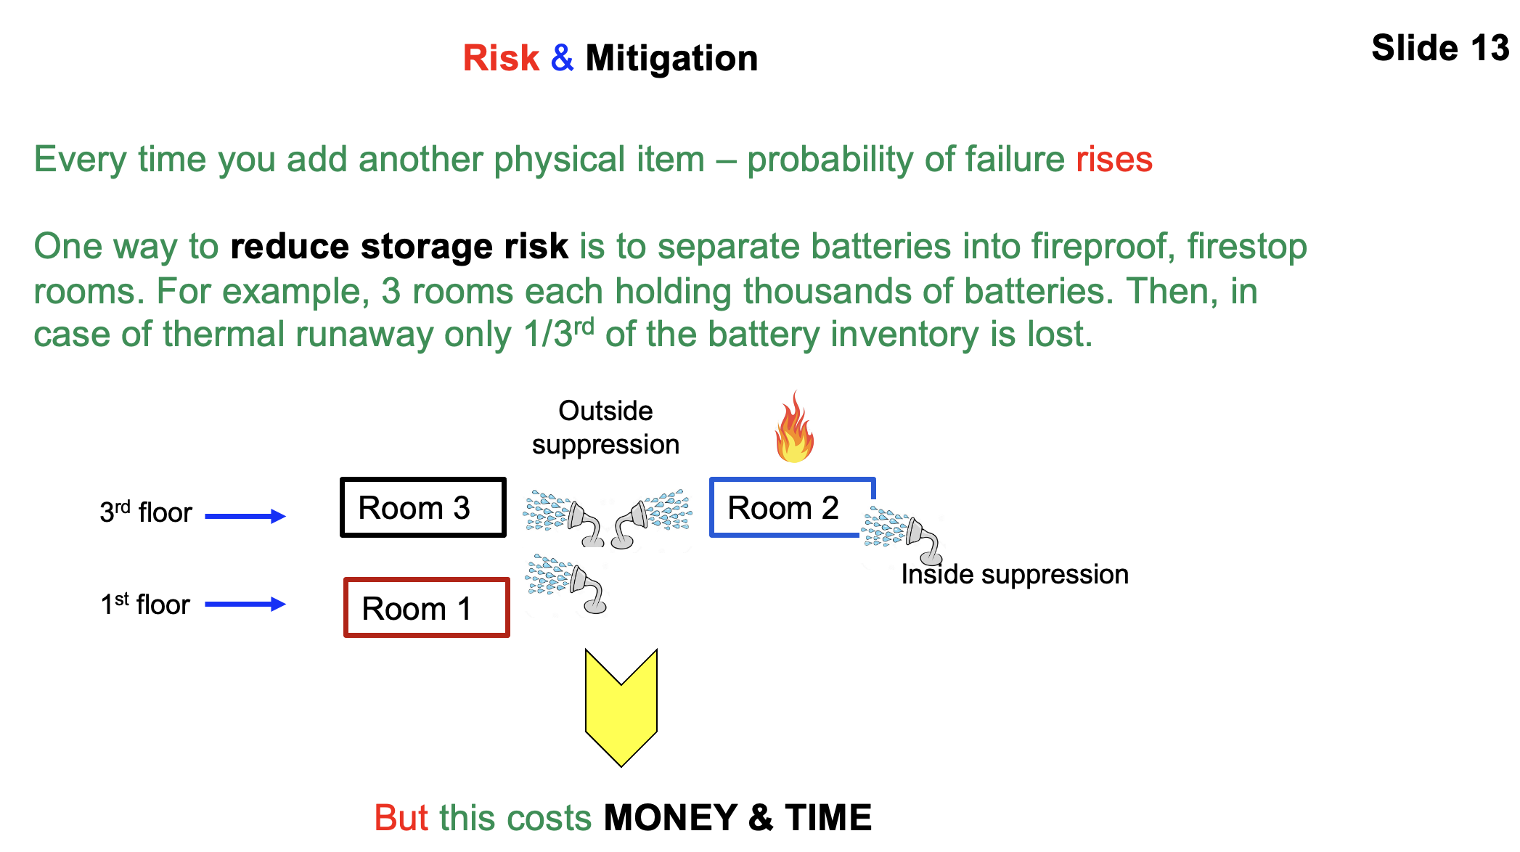

Site Risk: Vistra recognized that the Moss Landing energy site that had been in operation for 69 years had significant advantages as a heavy metal battery storage site. In place electric grid connections would cut installation time and costs. The property provided room for additional outdoor and indoor storage facilities. It was an ideal location near Silicon Valley to help solve regional energy needs. Plus, it was a County supervised site that would avoid city regulations against energy storage operations. So, Vistra purchased the site and petitioned Monterey County to approve its multi-phased energy storage project.

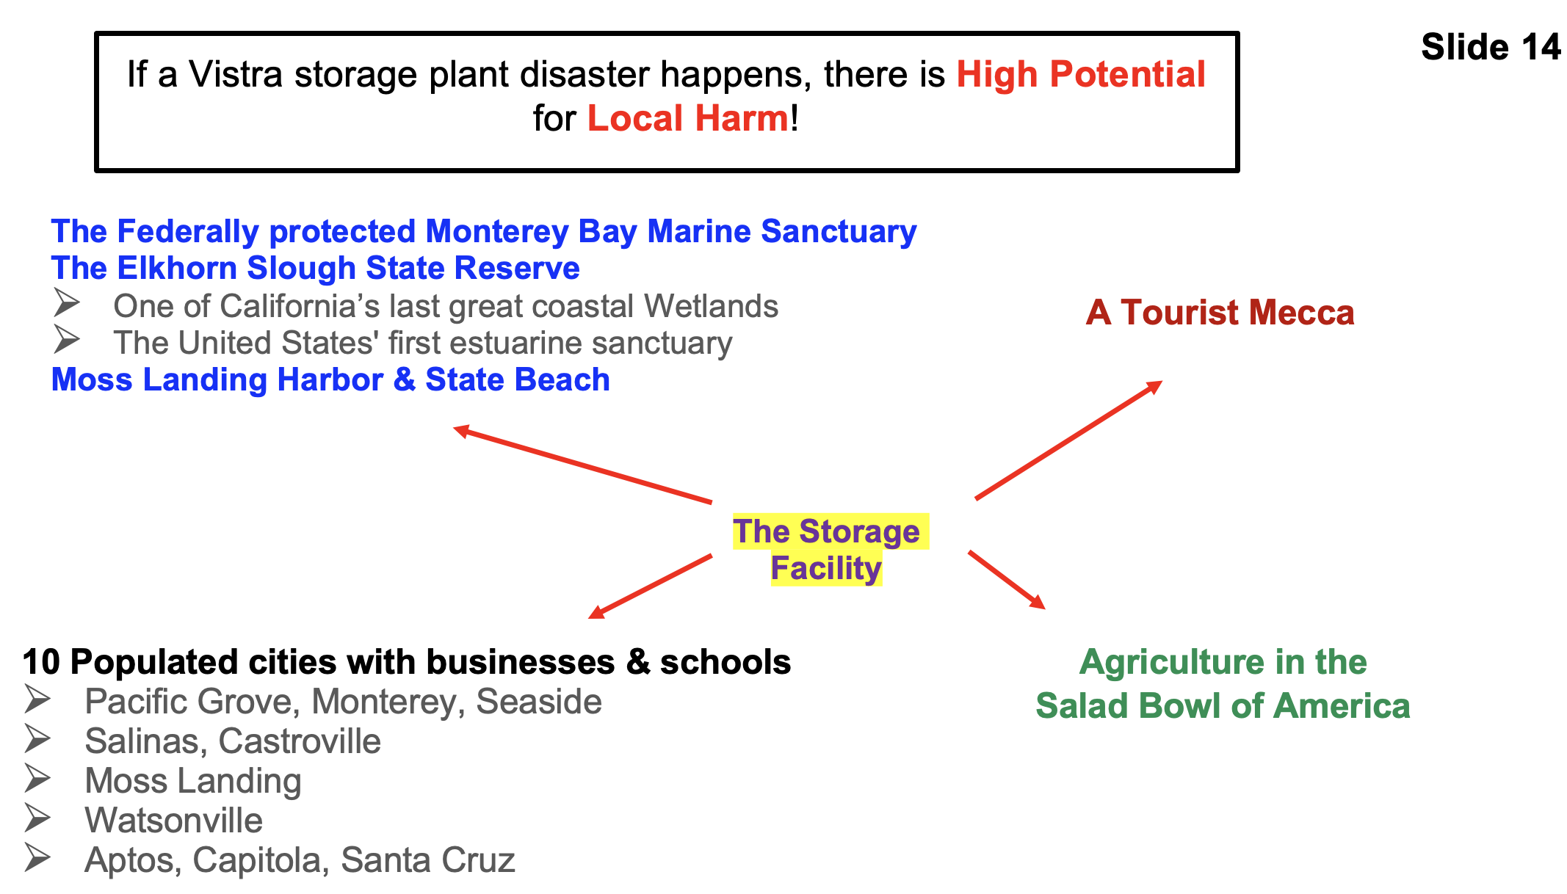
However, there was one big downside. See Slide 14.
Vistra decided to plant the largest lithium battery storage facility in America in the middle of the Monterey Bay Coastal area, which is the number one or number two worse place along California’s coast to positioned their industrial operation. A site where if a major incident occurred at the Phase-I facility, there were multiple sensitive targets for enormous potential harm:
>> Positioned beside two environmental gems — the U.S. Monterey Bay Marine Sanctuary
and the California State Elkhorn Slough Reserve.
>> Upwind from the Salad Bowl of America which is one of America’s highest producing
agriculture region.
>> Populated with 10 cities curving from Santa Cruz in the north to Pacific Grove in the south
>> Positioned in an internationally-known tourist mecca, where nearly every three-day weekend
up to a thousand cars carry tourist visitors past Moss Landing.

Basically, from a site risk standpoint, Vistra gambled that there wouldn’t be an uncontrollable thermal runaway that would overwhelm their building’s suppression and containment system. Unfortunately, as the sun was setting on January 16th KION and KSBW TV broke into their regular news reporting and sent pictures to the whole world of the huge, unstoppable fire at Moss Landing. Then, Monterey Bay coastal families, from Santa Cruz in the north to Pacific Grove in the south, witnessed the result of risk-taking in the Moss Landing storage building. Vistra was wrong and the coastal public and environment are now paying the price!

Financial Risk: To outsiders it seems, that Vistra’s design team for some reason thought that there was no way that they could fail to suppress and contain any row-unit fire or explosion. Therefore, Vistra’s leadership accepted the risk of the company suffering huge financial losses if they were wrong. Clearly, previous slides 1 and 2 prove they were wrong and the company has lost:
>> Its sunk costs to design, build, test, and populate the Phase-1 facility
>> One or more years of storage and discharge income
>> Facility replacement costs
>> Possible near- and long-term litigation costs, to make harmed businesses and individuals
whole.
>> Possibly higher future insurance rates

Four Operator Risk Findings:

Risk #1 Vistra followed a high-risk storage layout and operation strategy that failed and cost the company dearly.

Risk #2 Vistra willingly chose to position its industrial operations in a coastal area, thus placing the Monterey Bay Coastal environment, tourism, agriculture, and citizens at high risk of being harmed from a major failure at its first-of-its-kind facility.

Risk #3 Vistra failed to protect and thus endangered the Monterey Bay Coastal environment, businesses, homes, and people from a vaporized, heavy metal, dioxin-laden pollution cloud and surface residue.

Risk #4 CEO Morgan was correct that Vistra’s Moss Landing project would, as it is now, serve as the model for utility-scale battery storage for years to come. Unfortunately, the project became a model for what not to do as of January 16, 2025, when the largest single-building high-quantity, indoor battery storage facility in America burned down.

Now, Never Again Moss Landing and the residents of our region demand that the authorities take the appropriate and necessary steps to determine if Vistra was negligent in its storage operation.

<<<<<<<<<<<<< >>>>>>>>>>>>

Section-7 PUC Regulator-Level Details
See Slide 15. The Never Again Moss Landing investigation team has found numerous actions that the State’s public utility regulator and supporting agencies have failed to perform during the Vistra Moss Landing disaster. We also found public safety actions not performed going back to the first lithium battery storage fire incident within California beginning April 5, 2022.
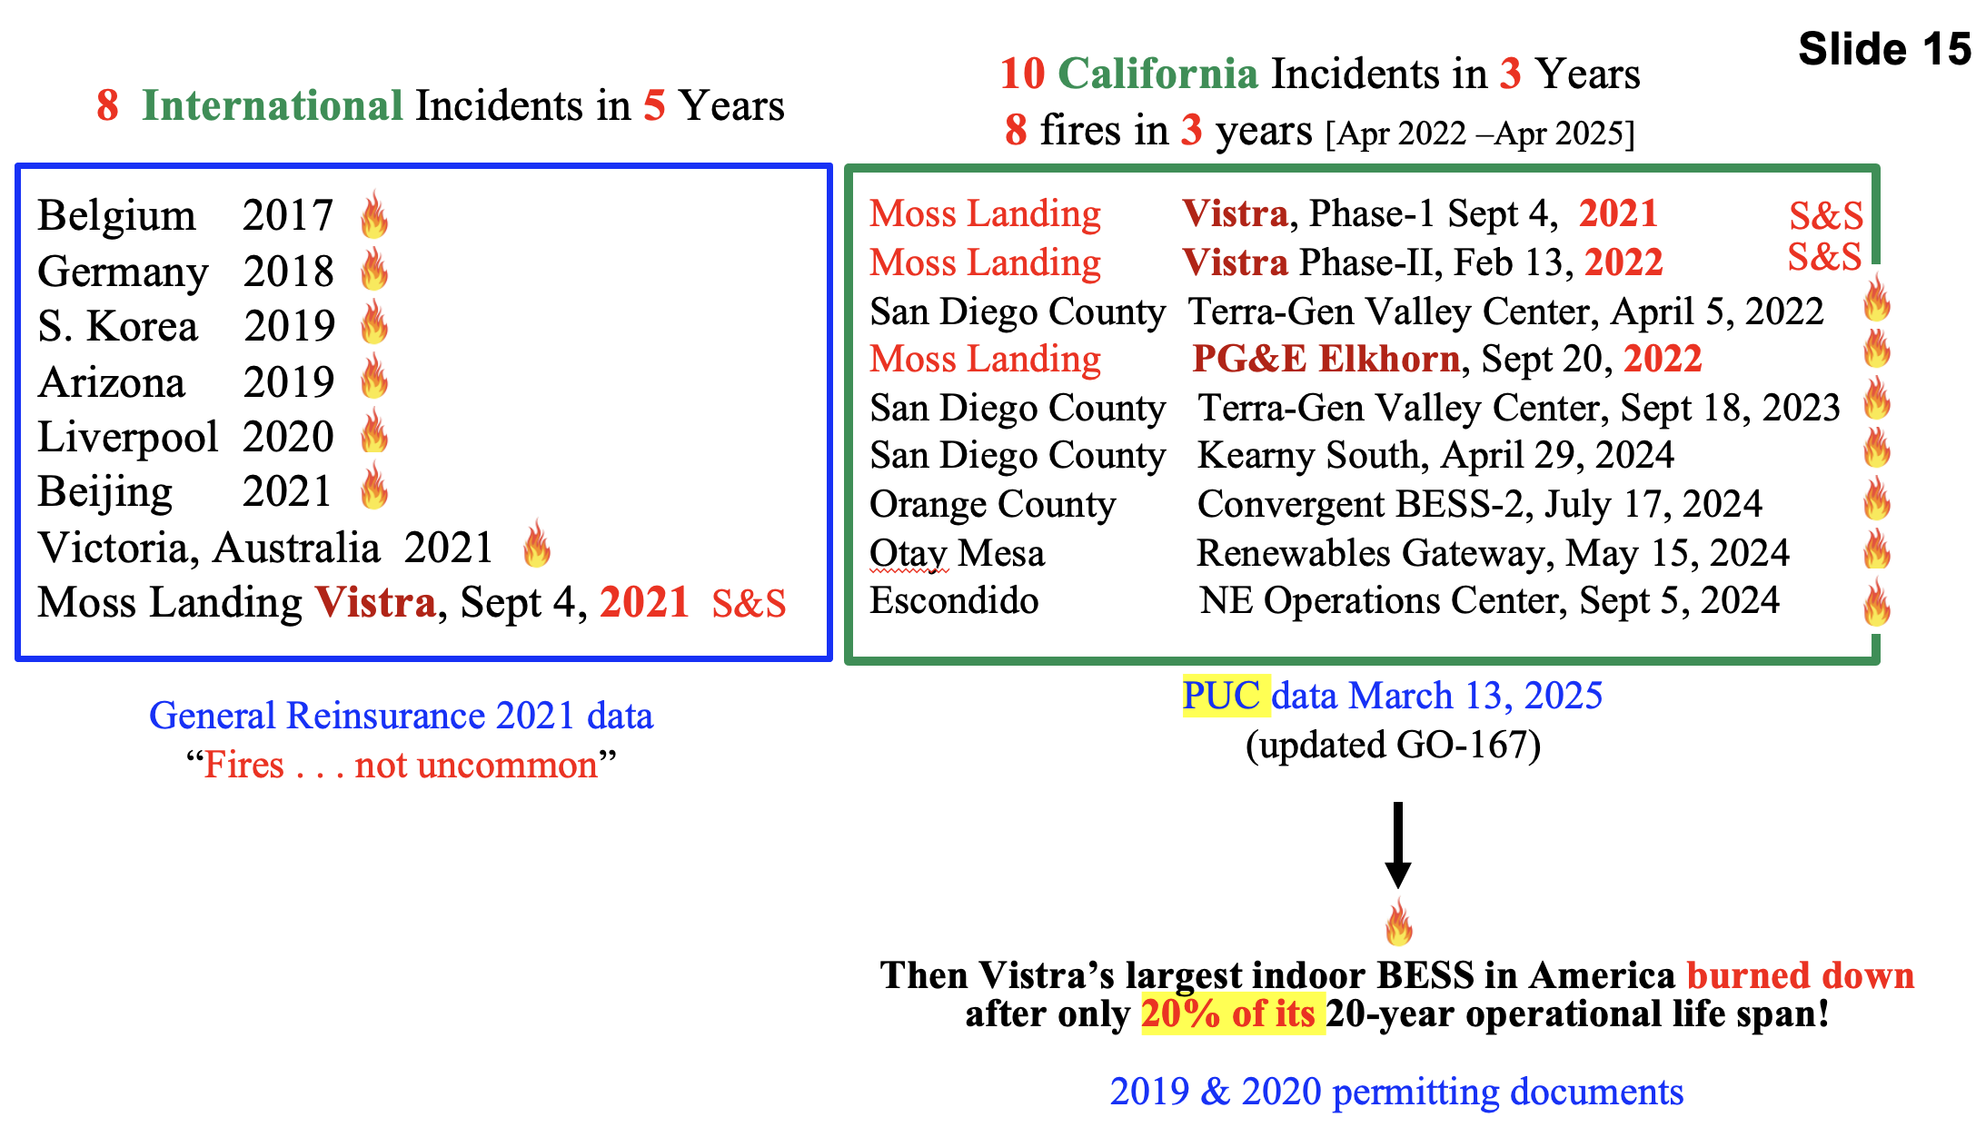

California’s PUC regulator is well informed of the number and size of lithium battery storage fires repeatedly, and annually occurring overseas, in other U.S. states and in California. Disasters that have and continue to place the public at risk from fire, explosions, and heavy metal vapor/cloud releases. However, the PUC, nor any other state agency, have not gathered or provided any incident samples revealing the public health hazard of battery fire vapor emissions. For example, while the PUC has a 2017 policy for flying drones to gather data of construction occurring in San Francisco, and policies for drones being used for safety purposes at airports, it does not have a policy to use drones to do aerial sampling at multiple altitudes after an outdoor or indoor lithium battery facility goes into uncontrollable thermal runaway.

Of concern is:
- The steady growth in the number of incidents in California and the difficulty to determine the root cause of the failures in the majority of cases.
- Worldwide, where root cause is determinate, the largest cause – 36% - was “Integration, Assembly & Construction.”
- Worldwide, the vast majority of incidents occur in the initial 3 years of operation.
- Worldwide, fully 46% of failures are due to system controls.

The PUC staff and board members have a legislative duty to act upon this history to prevent harm to the public and the environment. It has not taken adequate action to mitigate these troubling factors.
See the 2023 EPRI analysis here: https://neveragainmosslanding.org/wp-content/uploads/2025/03/Insights-from-EPRI_s-Battery-Energy-Storage-Systems-_BESS_-Failure-Incident-Database_-Analysis-of-Failure-Root-Cause-1.pdf

See Slide 16. For example before the Vistra disaster and still now, California’s PUC regulator, has not issued installation, safety, and operating codes for single-building, high-density, indoor, lithium battery storage facilities. Instead, the California Public Utilities Commission depended upon self-policing by the storage facility operator to choose the maximum number of batteries they would store in one building, if any firestop rooms would be in the building, distancing between row units, or how the operator would establish and test an adequate room or building suppression and containment capability. How well has self-policing turn out for California? Slides 1 and 2 prove that regulatory approach failed to protect the public and the environment from safety or reliability failures.

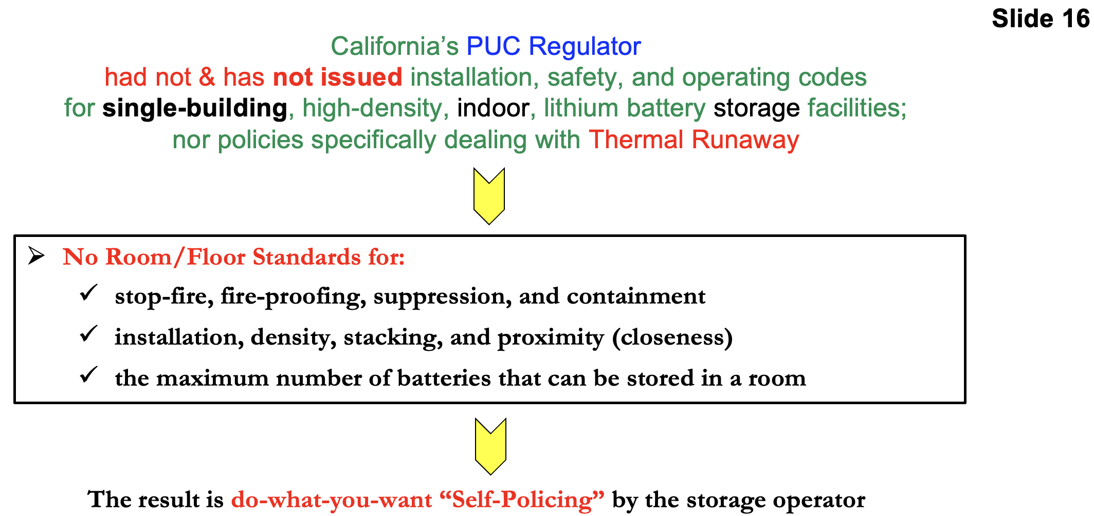

Another self-policing example is that before the Vistra disaster, and still now, California’s PUC regulator does not require operator and county fire emergency response teams to discuss and specifically plan how to handle thermal runaway events. Unfortunately, the PUC has not and does not use the words thermal runaway or thermal runaway events in its policy and regulation documents. Such avoidance behavior occurred during the March 13, 2025 CPUC hearing to ratify modifications to General Order 167 (Maintenance and Operations). Though NAML attendees urged the PUC commissioners to address single-building thermal runaway response plans, nearly two months after the Vistra single-building storage facility burnt to the ground — the commissioners did not add the phrase, thermal runaway.

Additionally, the PUC knew or should have known that Vistra’s single-building high-density storage was high-risk and needed fixes. At a minimum, they should have inspected the to-be-built drawings and layout plan, then later inspect the actual layout of the 100,000 batteries, and then approve or disapprove. Unfortunately, whatever approval process that the PUC followed — it did not protect the public.

The PUC and other State agencies arrived at the huge Vistra Battery fire unprepared for such a fire. For example, while the fire was burning, neither the PUC nor any other State agency arrived with meters or means to measure heavy metal or dioxins around the fire site or in the air. While the fire was burning, neither the PUC nor any other State agency drove into the Royal Oaks and Prunedale downwind area, to take air samples, where the pollution cloud lingered down to ground level. Nor did any state agency arrive with a drone sampling capability. Plus, while the fire was burning, neither the PUC nor the California Health Department issued a medical alert to Central Coast public and private medical centers with information about the symptoms of heavy metal or dioxin exposure. That medical data was issued later.

See Slide 17. Now, here’s example of doing a little and not doing a lot by the California Department of Toxic Substances Control (DTSC). Eight days after the fire began, the department did sample several places where citizens were not restricted from traveling through during the fire. But they did deem it unnecessary to do similar sampling inside the perimeter fence where Vistra employees and County first responders worked during the fire. Nor did they take any downwind samples of dioxins, while ignoring the 124 downwind samples gathered by the Never Again Moss Landing team.

Unfortunately, the above-described non-actions by the PUC and other state agencies creates the appearance that the PUC’s leadership was, and remains, too focused on delivering future storage facilities and not enough on delivering public safety. Thus, when it comes to lithium battery storage, the PUC has failed to live up to its mission statement as stated on the PUC’s Electric Safety and Reliability Branch (ESRB) web page. We quote: “. . . to ensure that the facilities are operated and maintained in a safe and reliable manner to protect and promote the public health and safety.”

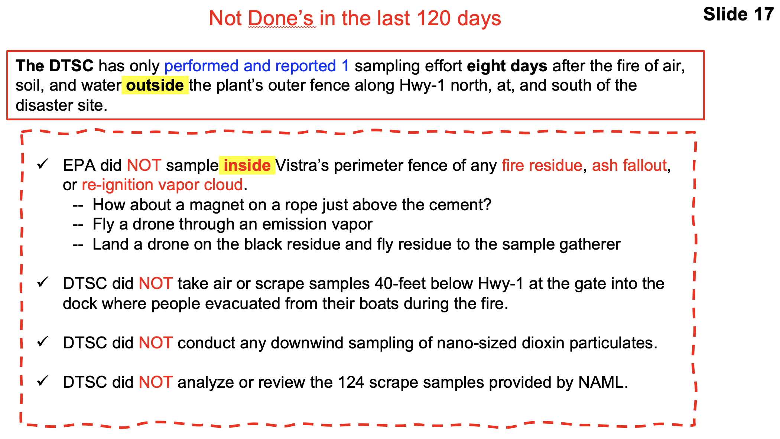

Eight Regulator-Level Findings:
RL #1 California’s PUC Regulator before the Vistra disaster and still now, has not issued installation, safety, and operating codes for single-building, high-density, indoor, lithium battery storage facilities and dealing with single-building thermal runaway events at the row-unit and building level.

RL #2 Regarding the Vistra public utility, the PUC regulator failed at its mission to protect the Central Coast people, businesses, and environment because it allowed too much do-what-you-want self-policing by the Vistra storage operator.

RL #3 The PUC knew or should have known that Vistra installed and operated a high-risk single-building, high-quantity, indoor storage layout, that was prone to completely burn up all the batteries on a storage floor if uncontrolled thermal runaway erupted.

RL #4 The PUC allowed Vistra to operate and put at risk Federal & State coastal sanctuaries/reserves, the Salad Bowl of America, Monterey Bay area tourism, and ten Central Coast cities/towns.

RL #5 The PUC arrived at the huge Vistra Battery fire unprepared for such a fire to include not having a drone surveillance policy or plan to gather aerial samples of lithium battery hazards released during a lithium battery fire.

RL #6 No California state regulator or agency made any attempt to sample downwind vapor conditions for heavy metal and dioxin exposure beyond the fire site. Nor did they sample soil and residue samples inside the perimeter of Vistra’s industrial site.

RL #7 State regulators failed to gather and report battery fire sampling data that might show dangers to first responders, workers, the public, environment, and agriculture fields, for “hazardous materials release” of hazardous chemicals, heavy metals, dioxins, PCBs, chlorinated compounds, or polyaromatic hydrocarbons (PAHs) in the Moss Landing fire’s vapor/cloud during the Vistra disaster. They only sampled for oxygen dioxide and hydrogen fluoride.

RL #8 Large lithium battery storage fires are common in California. According to PUC data, such fires have occurred annually since April 2022.

<<<<<<<<<<<<< >>>>>>>>>>>>

Section-8 Summary Findings

Eight Top Level Findings:
We do not know what triggered the thermal runaway ignition incident. We do know that battery thermal runaway created a rapidly expanding uncontrollable fire that the building’s suppression and containment systems failed to suppress and contain.

See Slide 18. Based on the listed irrefutable facts, evidence, and risk assessment insights we found eight top-level factors contributed to how and why the Vistra disaster occurred. Two factors at the County permitting level, four factors are at the Vistra operator level, and two factors are at the California Public Utility Commission regulatory level. The regulatory factors should be disturbing to the public.

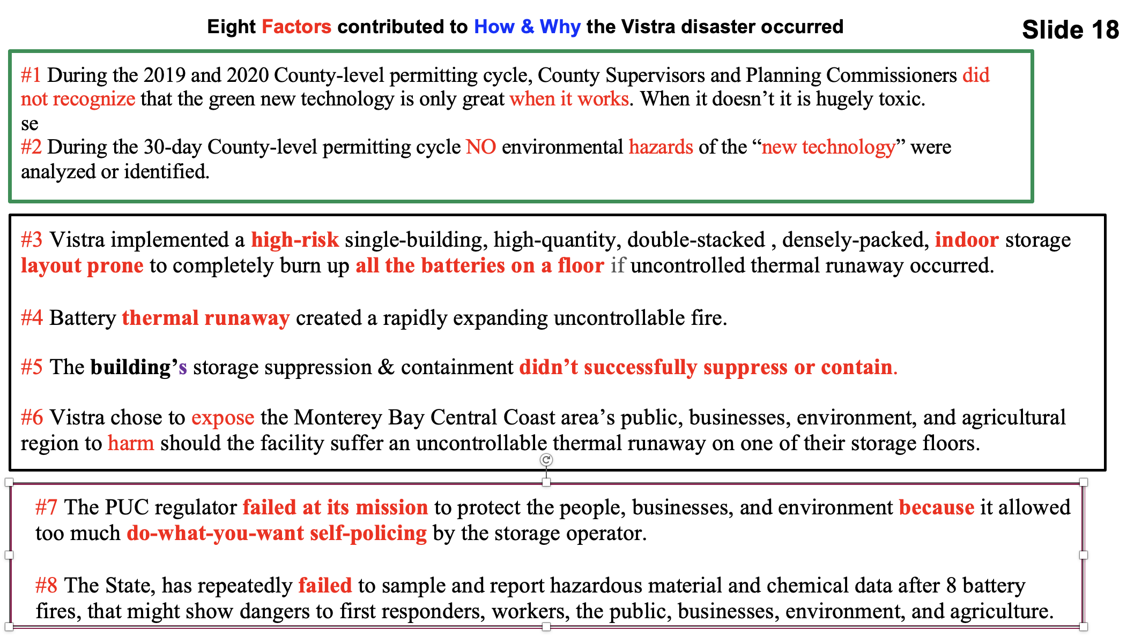

Six Operator-level Findings:
OL #1 Vistra build and operated the largest indoor lithium battery storage facility in America from December 11, 2020 until January 16, 2025 where it stored 100,000 heavy-metal lithium-ion nickel-manganese-cobalt batteries on the 1st and 3rd floors of its Phase-1 building.

OL #2 Multiple pieces of evidence verify that Vistra double-stacked & densely-packed batteries and row-units along the full length of the Phase-1 upper 3rd floor:
>> Slide-5: Vistra’s project request planned for double-stacked row-units on the 1st and 3rd
floors of the Phase-1 building.
>> Slide-7: Vistra’s website photo and the rack supplier’s press release photo show Phase-1
double-stacked racks allowed positioning twice as many batteries in the same row-unit
footprint.
>> Slide-8: Calculated indoor aisle spacing for 126 rows along 700 ft floor =
~5 feet 6-inch aisles
>> Slide-10: Vistra photo of employee in narrow Phase-1 aisle.
>> Slide-10: Vistra photo of the implemented 3rd floor double-stacked row-unit positioning.
>> Slide-11: Indoor aisle width much narrower than PG&E outdoor row distancing =
~8 feet 2 inches
>> Slide-9 & 10: Vistra photos showing no intervening walls or rooms on the 3rd floor.

OL #3 Storage facility operator (Vistra) installed and operated a single-building, high-quantity, indoor storage layout, that was prone to completely burn up all the batteries on a floor if uncontrolled thermal runaway erupted.

OL #4 The double-stacked densely-packed row-unit layout made it easier for thermal heating to jump across aisles and harder for the building’s suppression system to suppress.

OL #5 On January 16, 2025, the storage building’s suppression system failed to suppress and its containment system failed to contain. The suppression system either did not exist, did not rapidly initiate, was inadequate for the number of batteries exposed to thermal runaway heat, or it failed to operate.

OL #6 Vistra’s Phase-1 Moss Landing indoor battery storage facility completely burned down after only on-fifth of its planned 20-year operating lifespan, with the complete loss of the building and its stored inventory.

Four Operator Risk Findings:
Risk #1 Vistra followed a high-risk storage layout and operation strategy that failed and cost the company dearly.

Risk #2 Vistra willingly chose to position its industrial operations in a coastal area, thus placing the Monterey Bay Coastal environment, tourism, agriculture, and citizens at high risk of being harmed.

Risk #3 Vistra failed to protect and thus endangered the Monterey Bay Coastal environment, businesses, homes, and people from a vaporized heavy metal pollution cloud and surface residue.

Risk #4 CEO Morgan was correct that Vistra’s Moss Landing project would, as it is now, serve as the model for utility-scale battery storage for years to come. Unfortunately, the project became a model for what not to do as of January 16, 2025, when the “first” and largest single-building high-quantity, indoor battery storage facility in America burned down.

Eight Regulator-Level Findings:
RL #1 California’s PUC Regulator before the Vistra disaster and still now, has not issued installation, safety, and operating codes for single-building, high-density, indoor, lithium battery storage facilities, nor any codes for dealing with single-building thermal runaway events at the row-unit and building level.

RL #2 Regarding the Vistra public utility, the PUC regulator failed at its mission to protect the Central Coast people, businesses, and environment because it allowed too much do-what-you-want self-policing by the Vistra storage operator.

RL #3 The PUC knew or should have known that Vistra installed and operated a single-building, high-risk high-quantity, indoor storage layout, that was prone to completely burn up all the batteries on a storage floor if uncontrolled thermal runaway erupted.

RL #4 The PUC allowed Vistra to operate and put at risk Federal & State coastal sanctuaries/reserves, the Salad Bowl of America, Monterey Bay area tourism, and ten Central Coast cities/towns, including being built in a Tsunami flood zone.

RL #5 The PUC arrived at the huge Vistra Battery fire unprepared for such a fire to include not having a drone surveillance policy or plan to gather aerial samples of lithium battery hazards released during a lithium battery fire.

RL #6 No California state regulator or agency made any attempt to sample downwind vapor conditions for heavy metal and dioxin exposure beyond the fire site. Nor did they sample soil and residue samples inside or outside the perimeter of Vistra’s industrial site.

RL #7 State regulators failed to gather and report heavy metal sampling data that might show dangers to the public and environment for “hazardous materials release” of heavy metals, dioxins, PCBs, chlorinated compounds, or polyaromatic hydrocarbons (PAHs) in the Moss Landing fire’s vapor/cloud during the Vistra disaster. The only sampled for oxygen dioxide and hydrogen fluoride.

RL #8 Large lithium battery storage fires are common in California; they have occurred annually since April 2022.

Given the above investigation findings, Never Again Moss Landing red tagged the CPUC’s approved lithium battery storage site on February 8, 2025. The site is red tagged for high-risk operations leading to massive on-site and off-site pollution and threatening the safety of the public. Before lifting the NAML red tag, the Vistra storage site must be safely cleaned up and any future Vistra lithium battery storage operations beside Moss Landing must be verified as safe from thermal runaway.
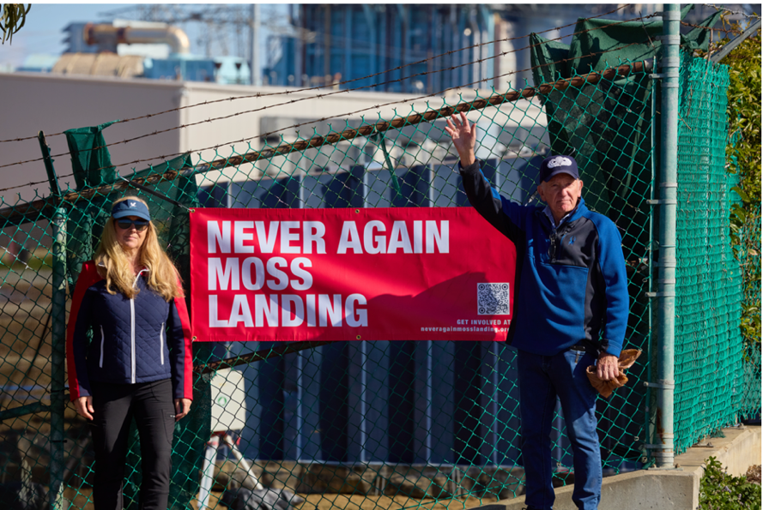

NAML Coordination Committee members Heather Griffin & Ed Mitchell
Photography by Richard Barnard, Copyright © 2025

<<<<<<<<<<<<< >>>>>>>>>>>>

Section-9: Needed State Investigation Questions

The CPUC, as regulator of Public Utilities, during its investigation of the Vistra thermal runaway fire that destroyed the Phase-I storage building, as a minimum must ask and get answers for the following 20 Investigation Questions:

Vistra Layout Design Questions:
#1 Determine who in Vistra approved Vistra’s interior safety and storage layout design, including the total number of batteries exposed to being burned up on a floor if the building’s suppression system failed?

#2 Determine if the large gap in the 3rd floor was replicated on the 2nd floor, thus turning the building into a single big room, and verify if the gap or gaps were ever closed and firestopped?

#3 Impound a copy of the “as built” blueprints held by Vistra or by Monterey County, and determine if the stored batteries were in effect held in a single room or several separate fireproof firestop storage rooms?

#4 Determine what, if any, firestop walls/barriers and ceilings were used to segregate portions of the 100,000 batteries into separate containable rooms to prevent the whole building from being engulfed in a thermal runaway fire?

#5 On what date, did the building’s interior floors/rooms achieve UL 1479 firestop certification?

#6 Determine the fireproof, firestop worthiness of the indoor storage building; was it a single huge room or was it split into separate fireproof, firestop protected floors/rooms?

Vistra Ignition-Suppress-Containment Questions:
#7 Determine what was the initial ignition event, why did the initial ignition event occur, why did the initial ignition event go into thermal runaway, why did the rack suppression and containment fail, why did the building suppression water spray system fail to suppress the thermal runaway, and why did the building containment system fail to contain?

#8 Determine what if any hardware and software changes were made to the building suppression system after the September 4th, 2021 smoke and suppression incident in the Phase-1 storage building and if the suppression system was tested after those changes were in place?

#9 Determine, after the ignition event, why the double-stacked rack’s suppression and containment did not prevent thermal runaway heat jumping to other row-units.

#10 Determine the spacing distance between double-stacked row-units and whether the separation distance was more than, equal to, or less than outdoor cargo container separation distances at the nearby PG&E-Tesla outdoor storage area.
#11 Determine why didn’t the design of the battery storage layout prevent 80% of the batteries from being burnt up and 100% of the batteries being a total loss?

#12 Determine how much fire suppression water was used during the fire, and how much flowed into the Moss Landing Bay or into the Elkhorn Estuary?

#13 Given the answers to the above questions, determine what were the safety and operational weaknesses of Vistra’s storage layout of 100,000 batteries in one building?

PUC Oversight Questions:
#14 Determine who in the PUC approved Vistra’s interior storage layout, including the total number of batteries exposed to being burned up on a floor should the building’s suppression system fail, the number of firestop rooms, the number of batteries per room, spacing distance between row-units, and the building’s suppression and containment systems?

#15 Determine when and how many times did PUC’s Safety Enforcement Division inspect Vistra’s indoor storage layout from design through installation of the 100,000 batteries.

#16 Determine why the PUC has not taken downwind aerial sampling of vapor/cloud discharge from uncontrollable thermal runaway fires since April 2022; and why it is not prepared to conduct aerial drone sampling of hazardous discharges from BESS fires in California.

Safety Inspection Questions
#17 Inspect and ensure 3rd-party sampling of the fire residue along the burnt building’s floor, occurs immediately and before any demolition occurs at the burn site; to determine if there is proof that toxic pollutants are in the waste field? Then provide to the Coastal Commission and to the public insight into what pollutants were released into the plume or flowed into the estuary/bay.

#18 Inspect and determine that cleanup actions by a 3rd party, not Vistra, comply with the cleanup plan and do not endanger the public.

#19 Determine by Inspection if Vistra’s Phase-II 100MW single-building, is a single-room design, and if it has any design and/or containment defects that led to the Phase-I building’s destruction? This includes determining if fixes are needed before it returns on-line and connects to the California electric grid.

#20 Determine by Inspection if Vistra’s Phase-II 100MW single-building has layout, aisle spacing, and/or building suppression designs different and safer than Phase-1’s layout, aisle spacing, and building suppression system? If so, why weren’t those improvements installed in the Phase-1 building?



Eddie Mitchell
NAML Lead Investigator

